Year 3 Knowledge Organiser | Creating media: Video trailers |  |  | Focus: Computing
Key Vocabulary | Filming | Key Facts
Application A computer program, sometimes called an app.  Film editing software Software with editing abilities to cut, crop and add effects to video footage.  Graphics Use of images designed to communicate, demonstrate or promote something.  Sound effects Sounds to enhance an event or bring aspects to life in a film or other media (e.g. the whoosh of a time machine).  Time code Time references on film or animations.  Video Recorded moving pictures that can make up a clip or film.  Voiceover A voice recording which overlays a video or presentation. | Taking pictures from low down makes it seem like we’re looking up through the eyes of a smaller character.  Taking pictures from above can give a birds-eye view without being high in the sky.  Zooming in to someone’s face can focus on their emotions. | Transitions are visual effects than can be applied in between digital media (e.g. slides, images or video clips).  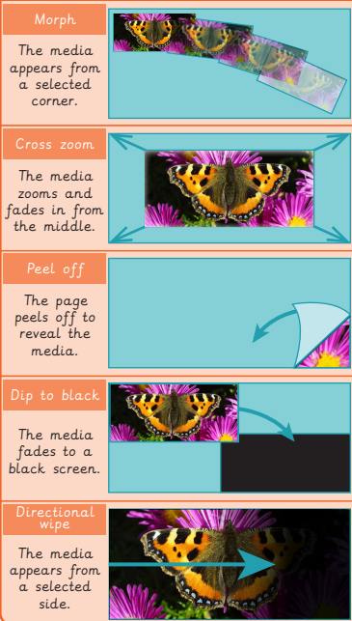
Editing | Sound
Upload helps import photos/videos.  Click and drag photos/ videos in the correct order on the timeline panel.  The ‘Audio’ tab has sound effects and background music you can use.  The ‘Graphics’ tab contains images for you to use. | Digital sound waves can be viewed and  edited on a computer.  They look like this:  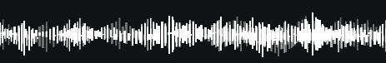  The taller the (vertical) line, the lounder the sound  is in that moment.

