Year 5 Knowledge Organiser | Data handling: Mars Rover 1 |  |  | Focus: Computing
Key Vocabulary | Binary | Key Facts
8-bit binary A way to send up to 255 different signals, with only eight on or offs.  binary code A computer code, based around the binary values of zero and one.  byte A unit of data which is eight digits long.  CPU Central Processing Unit - the 'brain' of a computer that deals with data it receives from input and output devices, as well as programs in the computer  data transmission The movement of information from one or more points to another.  radio signal A radio wave that is sent or received to somewhere.  RAM Random Access Memory - The computer's memory where instructions are stored while a program is running.  simulation Computer generated imitation of something such as a program test. | When a robot thinks independently, it needs to be able to calculate a range of data.  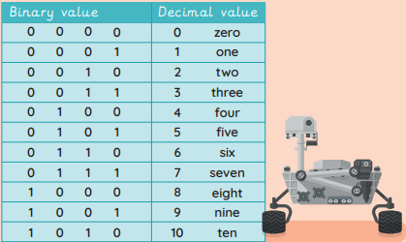  All decisions carried out by a robot, or any computer, are done in binary – including the Mars Rover. | The Mars Rover had to travel 350 million  miles (approximately) to get to Mars.
Mars Rover
The Mars Rover is a robot that scientists have sent to Mars to explore the planet’s surface. | 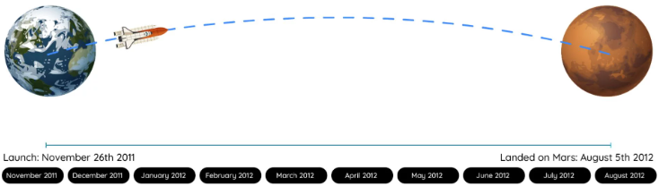  It took the Mars Rover Curiosity eight and a half months to travel from Earth to Mars.  The mission cost approximately £2.2 billion!  The Mars Rover found signs of water, suggesting there might have been life on Mars.

