Year 6 Learning Challenge (Summer 1)
The Anglo Saxons

Poem: | Beowulf (Epic)
Art Work: | The Anglo-Saxons were great craft workers. They made intricate jewellery, musical instruments and homemade toys and games. Study the carvings below and their meaning. Could you create your own shield, jewellery or game using some of the designs:  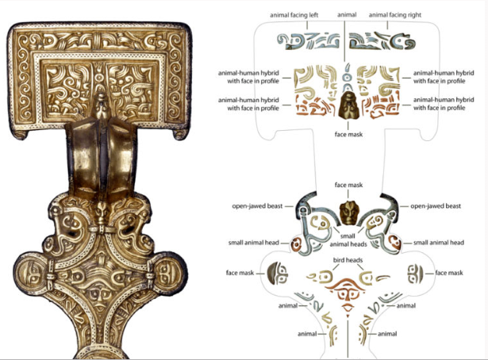  See following links for more information:  https://www.bbc.com/bitesize/articles/zwjq2hv  https://blog.britishmuseum.org/decoding-anglo-saxon-art/
Key People | Alfred the Great  Canute the Great (sometimes known as King Canute)
Events | Why not research and produce a factfile or leaflet about the following key events.  Anglo-Saxons defeat Norse at Stamford Bridge (1066AD)  Kingdoms established (i.e. Mercia etc) (600AD)
Music: | Research instruments from the time period (lyre etc.)

 | Poem | Art Work | Person | Music
Beginning | Learn it off by heart | Find out 10 facts about the painting/artist | Draw a portrait of the person | Listen to the piece of music and say what you like about it.
 | Find another poem by the poet | Produce a collage of other paintings by the artist | Produce a timeline of their life | Identify the instruments.
Secure | Create a performance as part of a pair/group | Draw a picture in similar style | Produce a poster to advertise their achievements | Research the life of the musician(s).
 | Write a short biography about the poet | Transform the medium of the painting: use collage instead of painting | Write a letter asking them about their life | Attempt to recreate the piece of music
Greater Depth | Write your own poem inspired by the topic | Use the image as a stimulus for a piece of descriptive writing. | Explain how the world would be without this person | A mind map of different emotions you feel at various points in the piece
 | Compare and contrast two poems by the poet | Describe the painting: what it represents, how it makes you feel, what it is based on. | Give five reasons for and against why they should be in ‘The Hall of Fame.’ | Produce a piece of art/collage based on how the music makes you feel.

